PRACTICAL 1A : 28 August 2020

Aim : Create an application that obtains four int value from the user and display the product.

Solution :

using System;

namespace Sigma.Practical

{

class OneA

{

static void Main(string[] args)

{

int num1,num2,num3,num4,prod;

Console.WriteLine("Abhijeet Sharma");

Console.Write("Enter the Number 1 : ");

num1 = Int32.Parse(Console.ReadLine());

Console.Write("Enter the Number 2 : ");

num2 = Convert.ToInt32(Console.ReadLine());

Console.Write("Enter the Number 3 : ");

num3 = Convert.ToInt32(Console.ReadLine());

Console.Write("Enter the Number 4 : ");

num4 = Convert.ToInt32(Console.ReadLine());

prod = num1 * num2 * num3 * num4;

Console.WriteLine("Product of four Number is " + prod);

}

}

}

Output :

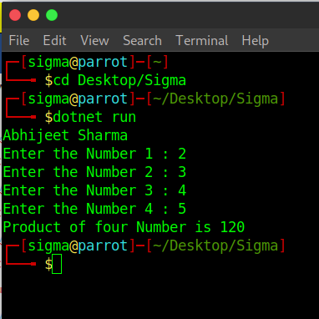

Practical 1B : 28 August 2020

Aim : Create an application to demonstrate string operations.

Solution :

using System;

namespace Sigma.Practical

{

class OneB

{

static void Main(string[] args)

{

string str1 = "", str2 = "DalmiaLionsCollege", new_str = "";

int n = 0;

Console.WriteLine("Abhijeet Sharma");

Console.WriteLine("In Uppercase: "+str2.ToUpper());

Console.WriteLine("In Lowercase: " + str2.ToLower());

n = str1.CompareTo(str2);

if(n==0)

{

Console.WriteLine("Both is equal");

}

else

{

Console.WriteLine("Both is not equal");

}

new_str = str2.Replace(" ", "");

Console.WriteLine(new_str);

}

}

}

Output :

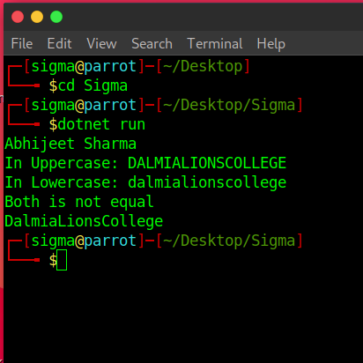

Practical 1C : 28 August 2020

Aim : Create an application that receives the (Student Id, Name, Course, Date of Birth) information from a set of students. The application should also display the information of all student once the data entered.

Solution :

using System;

namespace Sigma.Practical

{

class OneC

{

struct Student

{

public string studid, name, cname;

public int day, month, year;

}

static void Main(string[] args)

{

Student[] s = new Student[2];

int i;

Console.WriteLine("Abhijeet Sharma");

for (i = 0; i < 2; i++)

{

Console.Write("Enter student Id : ");

s[i].studid = Console.ReadLine();

Console.Write("Enter student name : ");

s[i].name = Console.ReadLine();

Console.Write("Enter Course name : ");

s[i].cname = Console.ReadLine();

Console.Write("Enter date of birth \t Enter day(1=31) : ");

s[i].day = Convert.ToInt32(Console.ReadLine());

Console.Write("Enter month(1-12) : ");

s[i].month = Convert.ToInt32(Console.ReadLine());

Console.Write("Enter year : ");

s[i].year = Convert.ToInt32(Console.ReadLine());

}

Console.WriteLine("\n\nStudent's List\n");

for(i=0;i<2;i++)

{

Console.WriteLine("Student ID : "+ s[i].studid);

Console.WriteLine("Student Name : " + s[i].name);

Console.WriteLine("Course Name : " + s[i].cname);

Console.WriteLine("Date of birth(dd-mm-yy) : " + s[i].day+ "-" +s[i].month +"-"+ s[i].year);

}

}

}

}

Output :

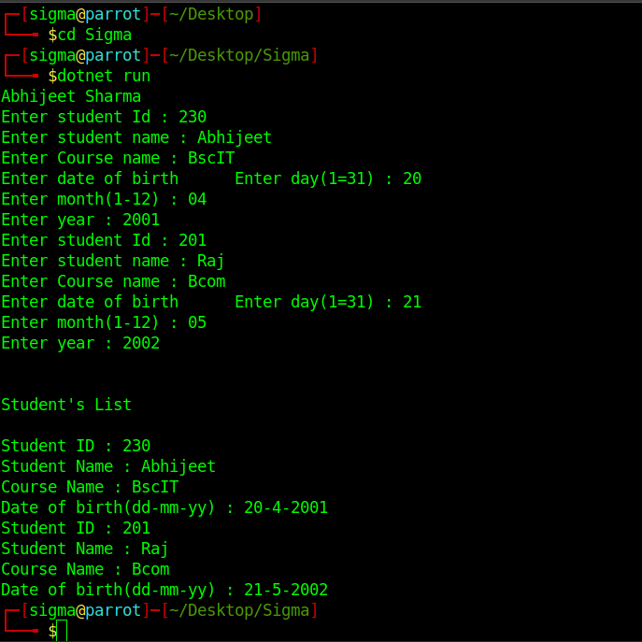

Practical 1D - 3 sept 2020

Aim 1 : Generate Fibonacci series.

Solution :

using System;

namespace Sigma

{

class Program

{

static void Main(string[] args)

{

int n1=0,n2=1,n3,i,number;

Console.Write("Enter the number of elements : ");

number = int.Parse(Console.ReadLine());

Console.Write(n1+" "+n2+" ");

for(i=2;i<number;++i)

{

n3=n1+n2;

Console.Write(n3+" ");

n1=n2;

n2=n3;

}

}

}

}

Output :

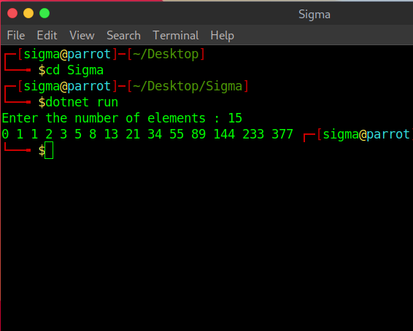

Aim 2 : prime numbers

Solution :

using System;

namespace Sigma

{

class Program

{

static void Main(string[] args)

{

int n, i, m=0, flag=0;

Console.Write("Enter the Number to check Prime: ");

n = int.Parse(Console.ReadLine());

m=n/2;

for(i = 2; i <= m; i++)

{

if(n % i == 0)

{

Console.Write("Number is not Prime.");

flag=1;

break;

}

}

if (flag==0)

Console.Write("Number is Prime.");

}

}

}

Output : 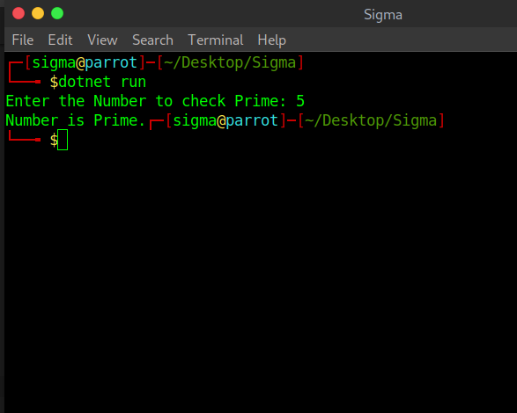

Aim 3 : test for vowels

Solution :

using System;

namespace Sigma

{

class Program

{

static void Main(string[] args)

{

char ch;

Console.WriteLine("Enter an alphabet");

ch = Convert.ToChar(Console.ReadLine());

switch(Char.ToLower(ch))

{

case 'a':

Console.WriteLine("Vowel");

break;

case 'e':

Console.WriteLine("Vowel");

break;

case 'i':

Console.WriteLine("Vowel");

break;

case 'o':

Console.WriteLine("Vowel");

break;

case 'u':

Console.WriteLine("Vowel");

break;

default:

Console.WriteLine("Not a vowel");

break;

}

}

}

}

Output

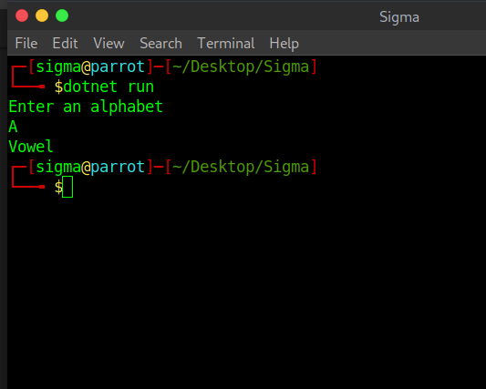

Aim 4 : Foreach loop

Solution :

using System;

namespace Sigma

{

class Program

{

static void Main(string[] args)

{

char[] myArray = {'H','e','l','l','o'};

foreach(char ch in myArray)

{

Console.WriteLine(ch);

}

}

}

}

Output :

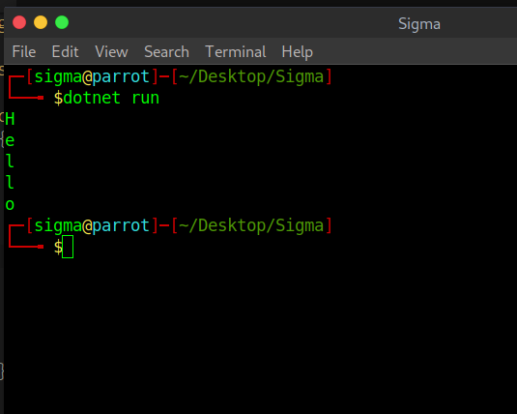

Aim 5 : reverse of a number and sum of digit

Solution :

using System;

namespace Sigma

{

class Program

{

static void Main(string[] args)

{

int num = 1234;

int rev_num = 0,digits = 0;

while(num > 0)

{

rev_num = rev_num * 10 + num % 10;

digits = digits + num % 10;

num = num / 10;

}

Console.WriteLine("Reverse of no. is "+ rev_num);

Console.Write("sum of digits "+ digits);

}

}

}

Output : 